**File that won't load:**

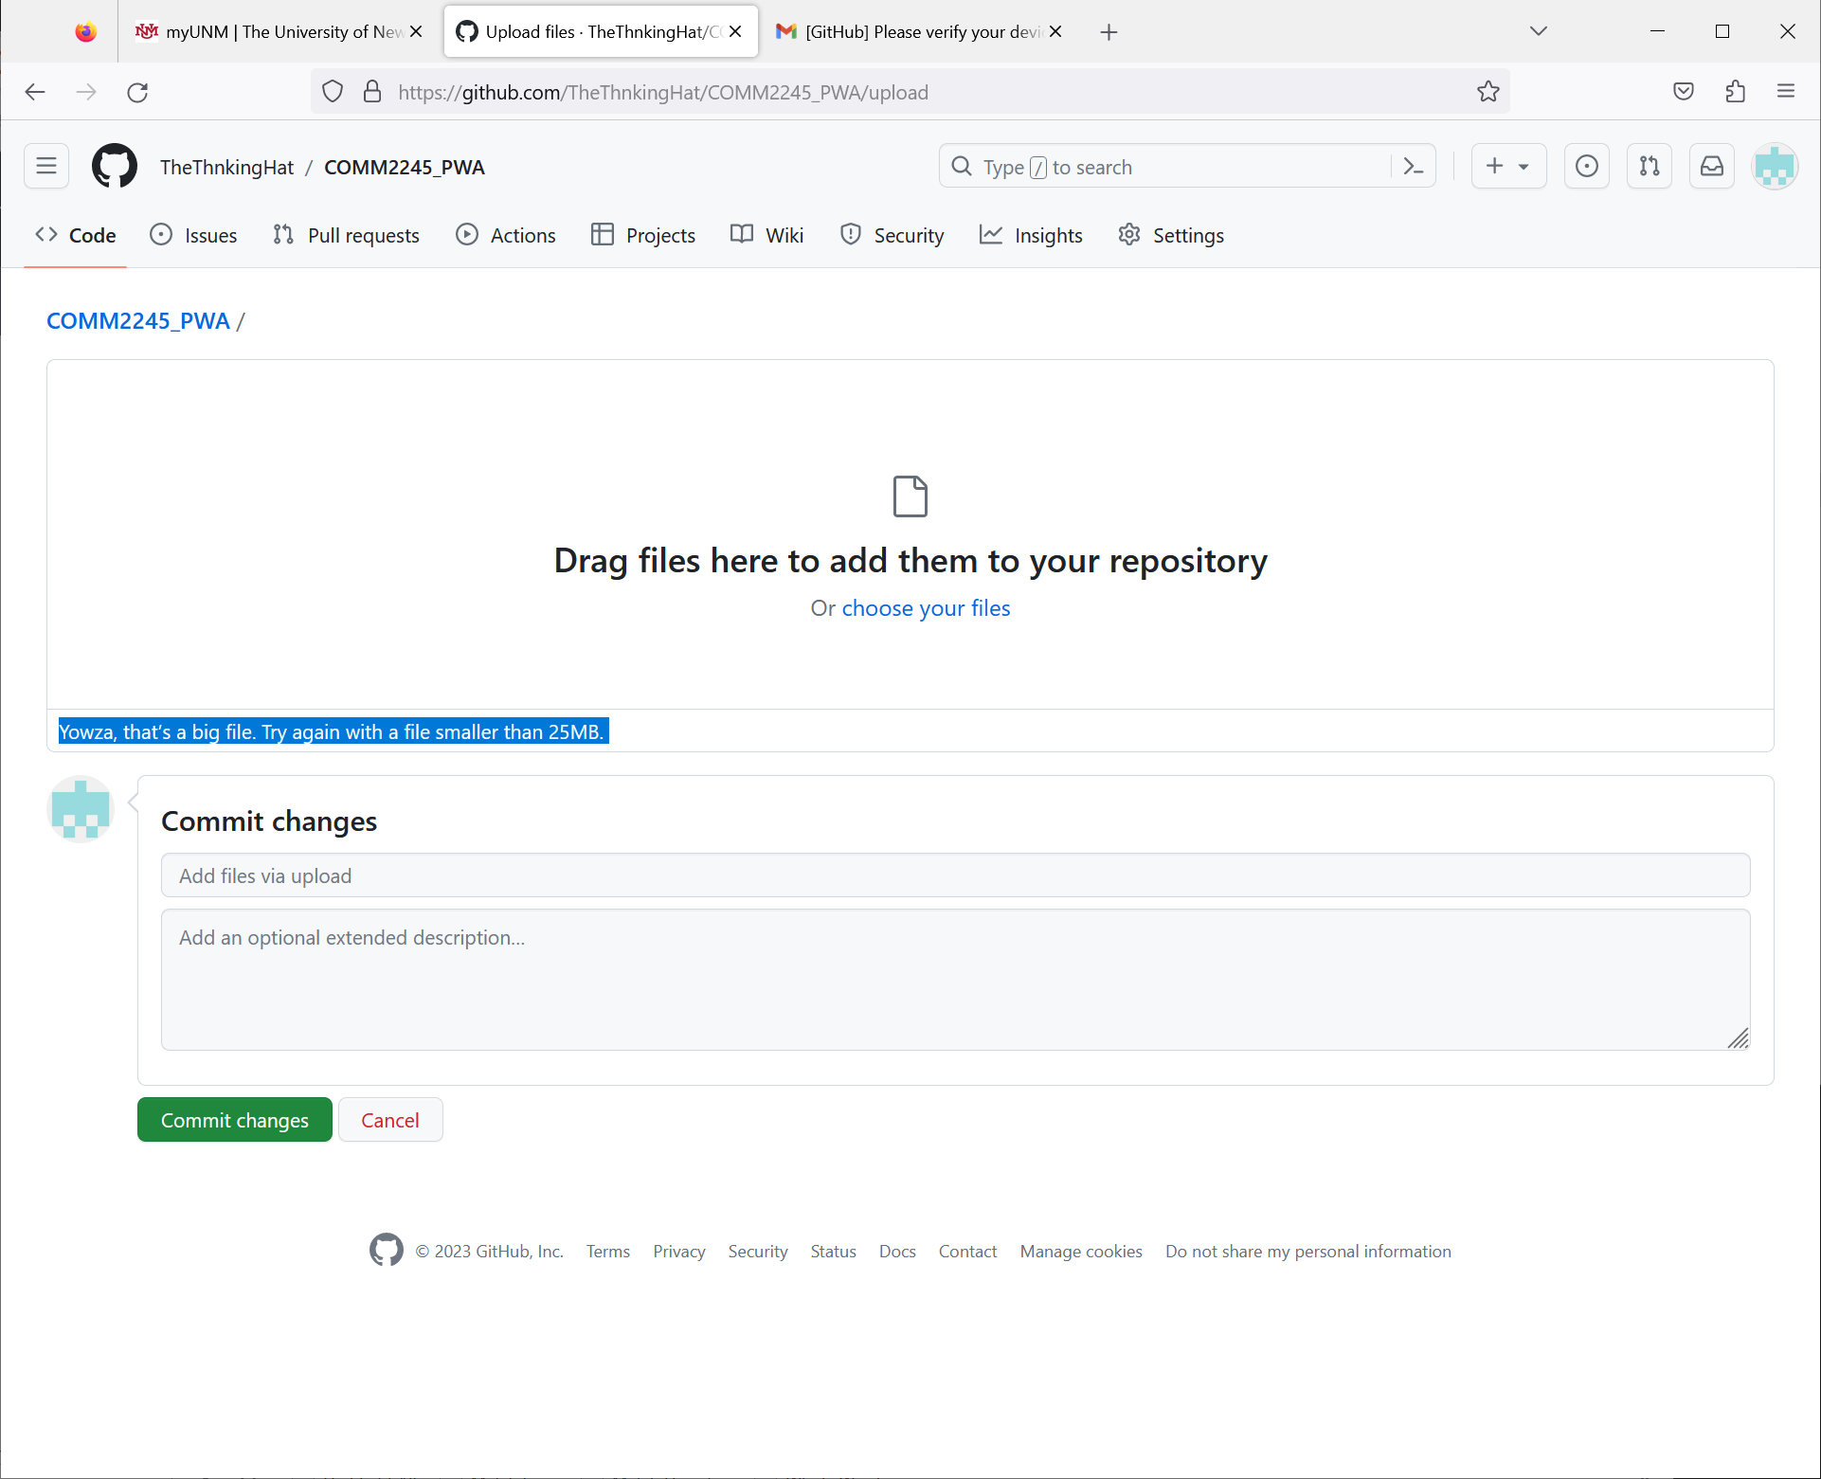

File that make up my personal webpage, that I can bring into Github. There is a 25MB limit. And the files below are as small as they can be.

1. VHW_Assignment
2. Johann Strauss II - The Blue Danube Waltz
3. Beethoven - Für Elise
4. Beethoven - Moonlight Sonata (1st Movement)
5. Beethoven - Symphony No. 5
6. Eine Kleine Nachtmusik - Mozart
7. Mozart-The Marriage of Figaro
8. vecteezy_abstract-space-blue-galaxy-with-stars-and-constellations_17692304
9. vecteezy_abstract-space-blue-galaxy-with-stars-and-constellations_17782831
10. vecteezy_alien-planet-with-rings-space-flight-4k_21571466
11. Rotating Earth Animation
12. Earth Render v2 aftereffects 2023 v c orb subscribe